2. Develop a Testimony using UML for implementing the Book Bank process. It should verify the details of the student by the central computer. The details regarding the student will be provided to the central computer through the administrator in the book bank and the computer will verify the details of the student and provide approval to the office. Then the books that are needed by the student will issue from the office to him.

***USE CASE DIAGRAM:*** 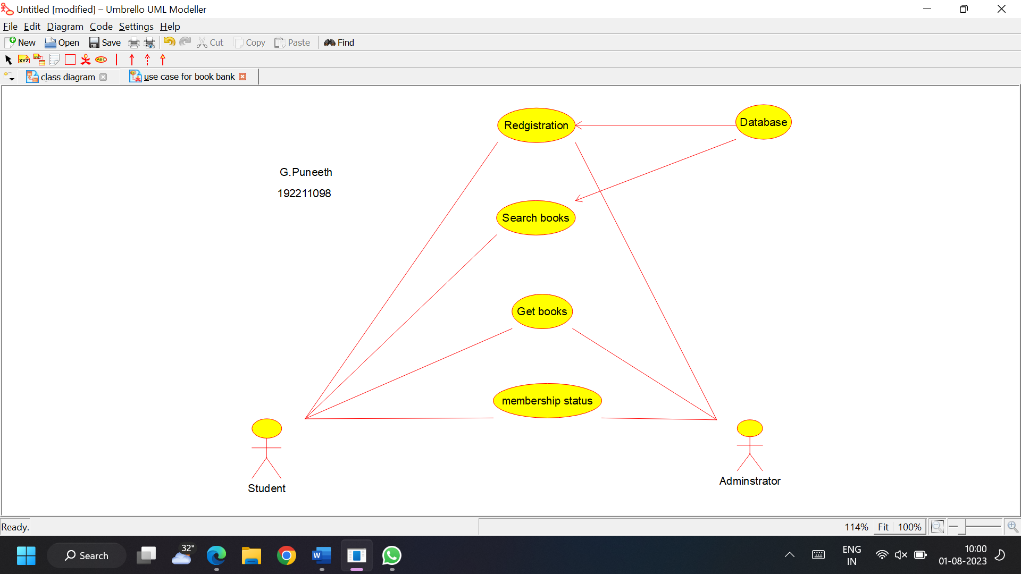



***CLASS DIAGRAM:***

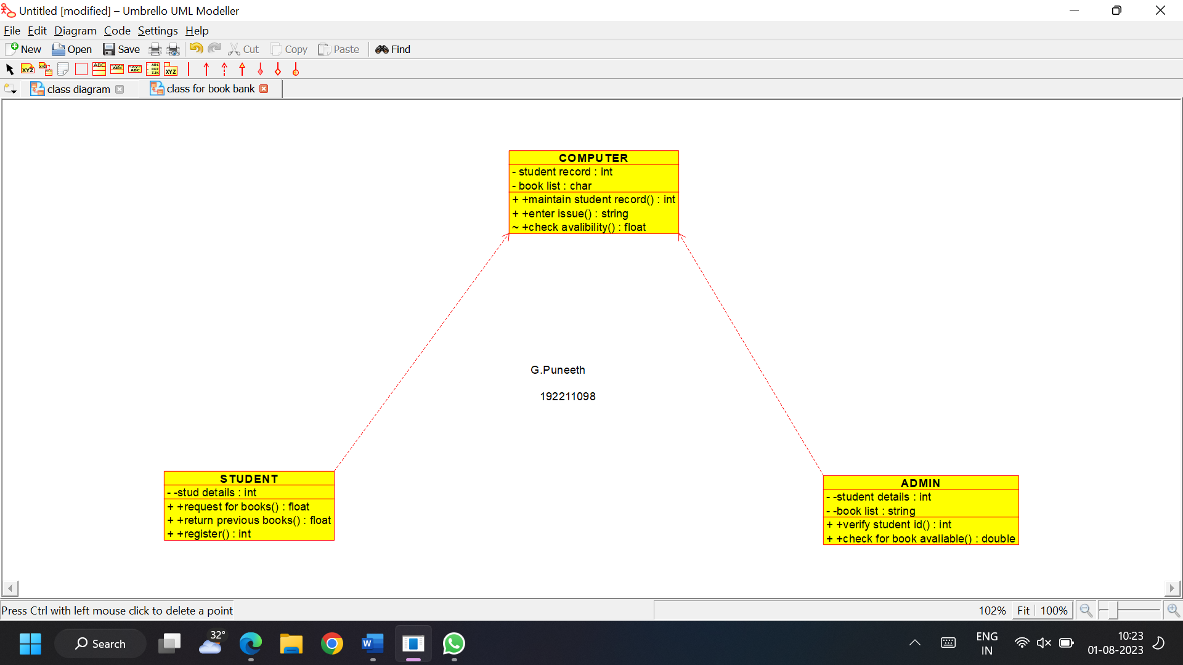

***ACTIVITY DIAGRAM:***

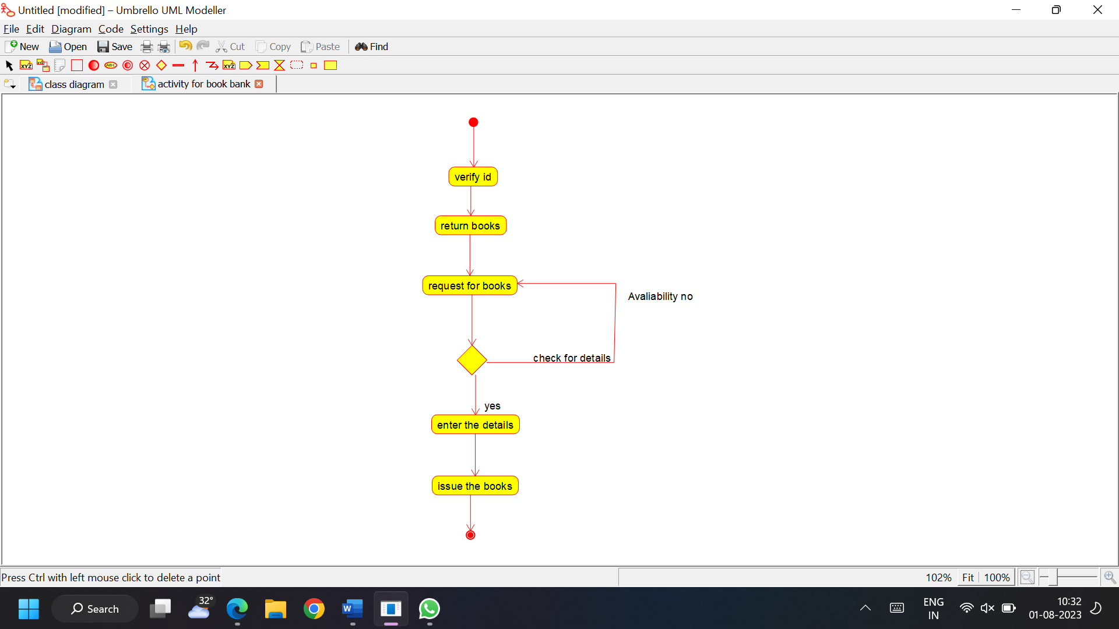

***STATE CHART DIAGRAM:***

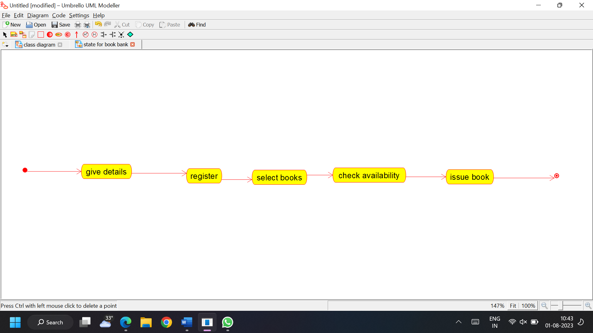

***SEQUENCE DIAGRAM:***

